Yes — you're exactly right, and your understanding is getting quite sharp. Let's lock this down clearly with some deeper reasoning.

✅ Padding: When & Why It’s Used

🔹 Padding is mostly needed during training and batched inference.
Scenario | Padding Required? | Why
Single sentence input | ❌ No | Model can dynamically handle input length
Batched input (inference) | ✅ Yes | All inputs in a batch must be same length → padding needed
Training (batched) | ✅ Yes | Same as above — batches must be uniform in shape

✅ Does this apply to decoder-only transformer models (like GPT/LLMs)?
Yes — even for decoder-only architectures like GPT-2, GPT-3, or LLMs like GPT-4, the same rule applies:
When batching sequences of different lengths, you need padding, whether you're using an encoder, decoder, or encoder-decoder model.
- GPT-style models don’t use [SEP], but they still need consistent tensor sizes across a batch.
- They will pad shorter sequences and mask those positions during attention or loss computation.

✅ HuggingFace Transformers + Trainer: Does it handle padding?
Yes! The Trainer class in HuggingFace automatically handles padding during training and evaluation — if you set things up correctly.

🔧 Key components that make this work:
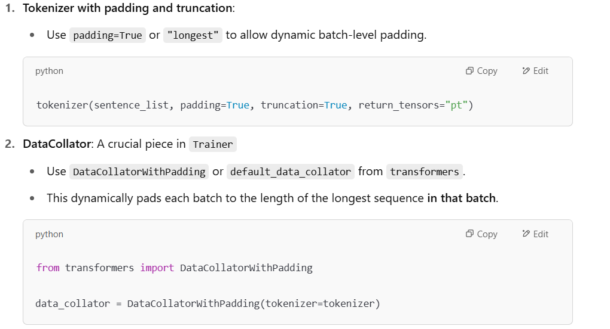
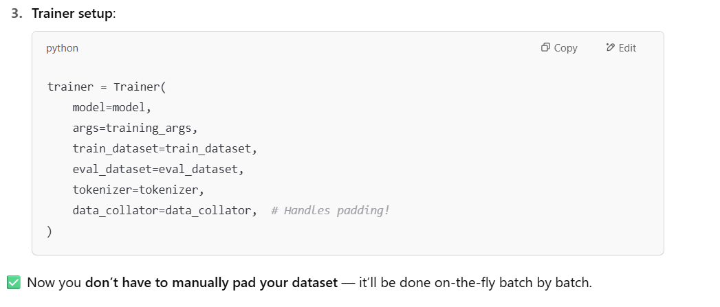.

🧠 Extra Insight: Padding Strategy Matters for Speed
Strategy | Pros | Cons
padding="max_length" | Simple; consistent tensor sizes | Wastes compute if sequences are short
padding="longest" (dynamic) | More efficient; pad only to batch max | Batches vary in shape (minor overhead)
So:
- For GPU efficiency and minimizing padding tokens, dynamic padding (longest) is better.
- For TPU or ONNX export, max_length padding may be required (fixed shape).

✅ Final Summary
Question | Answer
Is padding needed during training? | ✅ Yes, for batched input. Required by transformer models.
Is padding needed during inference? | ✅ If batching. ❌ If single input.
Does GPT/decoder-only model need padding? | ✅ Yes, if using variable-length sequences in batch.
Does HuggingFace Trainer handle it? | ✅ Yes, with a proper data_collator (e.g., DataCollatorWithPadding)
Can I skip padding? | ✅ Only if processing one example at a time (slower overall)

Let me know if you want a minimal working code snippet for training a HuggingFace model with dynamic padding using Trainer. I can walk you through it line by line.

